1120-医用输液器滴斗的3D打印生产记录
Medical infusion drip chamber
🖨️ 硅胶复模
🖥️ 打印机: Stratasys
📦 材料: 硅胶复模
在Twitter上看到有人因为输液器滴斗的问题找到我们，正是因为这个医用输液器滴斗，我们的技术才能更好地服务于人群。
I saw someone on Twitter reaching out to us regarding an issue with the IV drip chamber. It is precisely because of this medical IV drip chamber that our technology can better serve the community.
________________________________________________________________________________
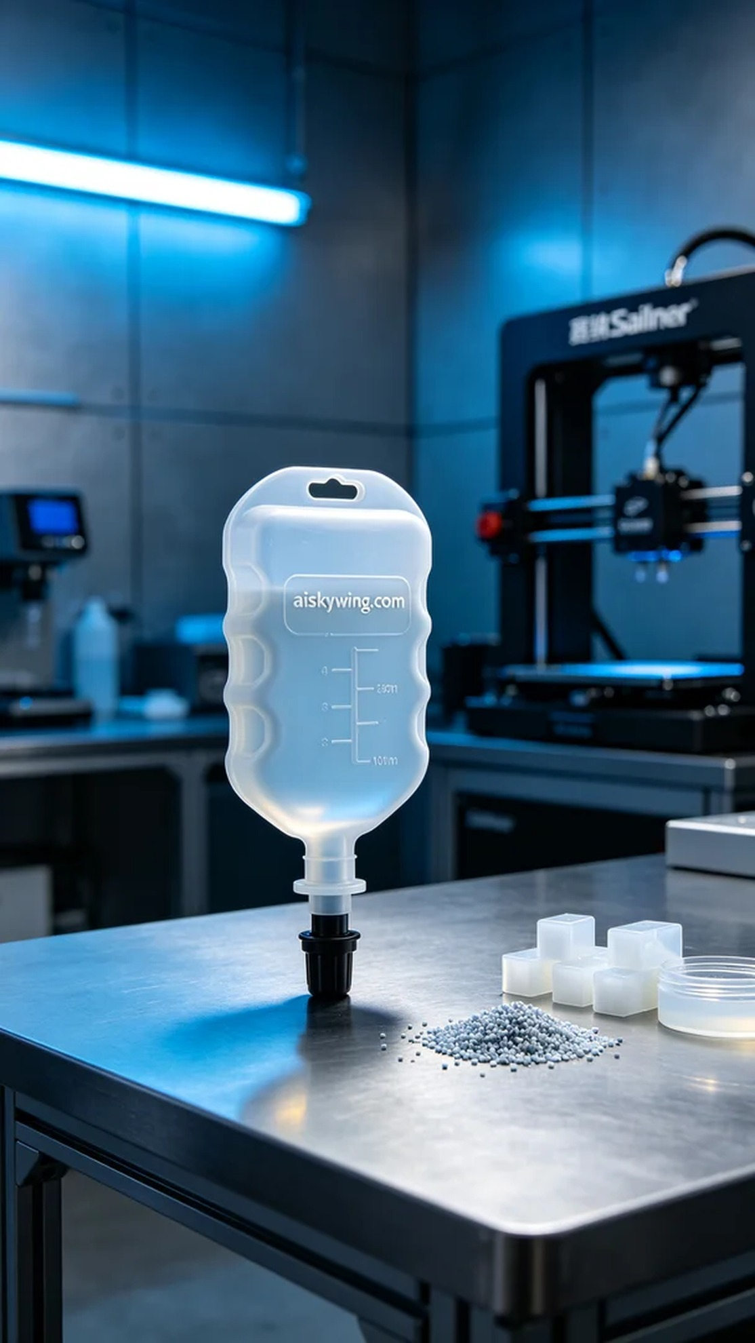
Recently, we received a request from a medical institution for the production of an intravenous infusion drip chamber. They faced difficulties due to their existing suppliers' inability to provide satisfactory products, so they turned to us for a solution using 3D printing technology.
We selected high-quality silicone casting material, known for its softness and durability, making it ideal for medical applications. For the equipment setup, we utilized a Stratasys 3D printer, configuring it with a layer thickness of 0.1 mm, a printing temperature of 60℃, a power setting of 80%, and a printing speed of 30 mm per second. The estimated printing time was around 8 hours to ensure detailed and stable final products.
During the printing process, the Stratasys printer operated smoothly while we closely monitored the progress. Each layer was meticulously checked to avoid any defects. The properties of the silicone casting material allowed for a smooth surface on the printed drip chamber, with the "aiskywing.com" engraving clear and reflecting the industrial lighting, creating a strong sense of technology.
After printing, we proceeded with post-processing steps. First, the printed drip chamber was placed in a cleaning solution to remove any residual liquid resin on the surface. Following that, we performed careful sanding to ensure smooth edges. Finally, we placed the product in a curing device to enhance its durability and stability, conducting rigorous quality inspections to ensure every detail was flawless.
Through this production, we successfully completed the intravenous infusion drip chamber, meeting the needs of the medical institution and showcasing the unique advantages and limitless possibilities of 3D printing.
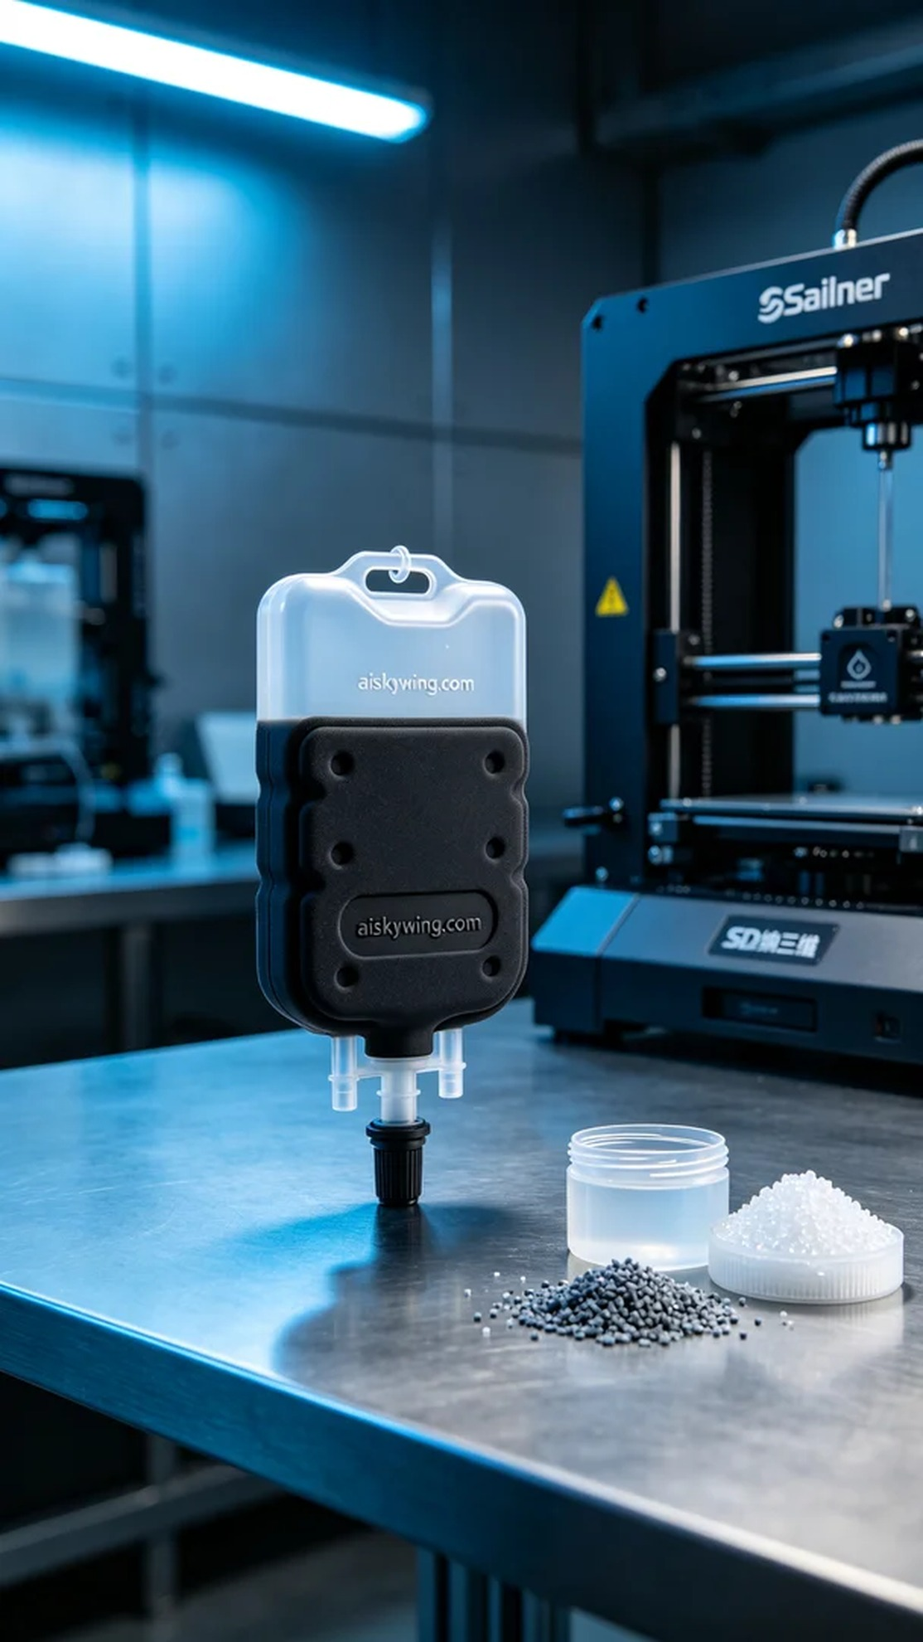
这次接到的任务是为一位医疗机构制作医用输液器滴斗。因为现有的供应商无法提供满意的产品，导致他们遇到了一些困难。于是，他们找到了我们，希望可以通过3D打印技术解决这个问题。
我们选择了高质量的硅胶复模作为原材料，具有柔软耐用的特性，适合医疗环境的需求。在设备准备上，我们使用了Stratasys 3D打印机，设置了层厚为0.1毫米，打印温度为60℃，打印功率为80%，打印速度为30毫米每秒，预计打印时间约为8小时。这样的参数可以确保最终产品的精致细节与稳定性。
在打印过程中，Stratasys打印机运转良好，我们密切监控着打印进度。每一层的打印都经过仔细检查，确保没有任何瑕疵。硅胶复模的特性使得打印出的滴斗表面光滑，清晰雕刻着"aiskywing.com"字样，反射出冷峻的工业光线，展现出强烈的科技感。
完成打印后，我们进行了后处理工序。首先，将打印好的滴斗放入清洗液中进行清洗，去除表面残留的光敏树脂。随后，经过细致的打磨，确保边缘平滑。最后，我们将产品放到固化设备中进行固化，以增强其耐用性和稳定性，最终经过严格的质量检验，确保所有细节完美无缺。
通过这次生产，我们顺利完成了医用输液器滴斗的制作，不仅满足了医疗机构的需求，也展示了3D打印的独特优势与无限可能。
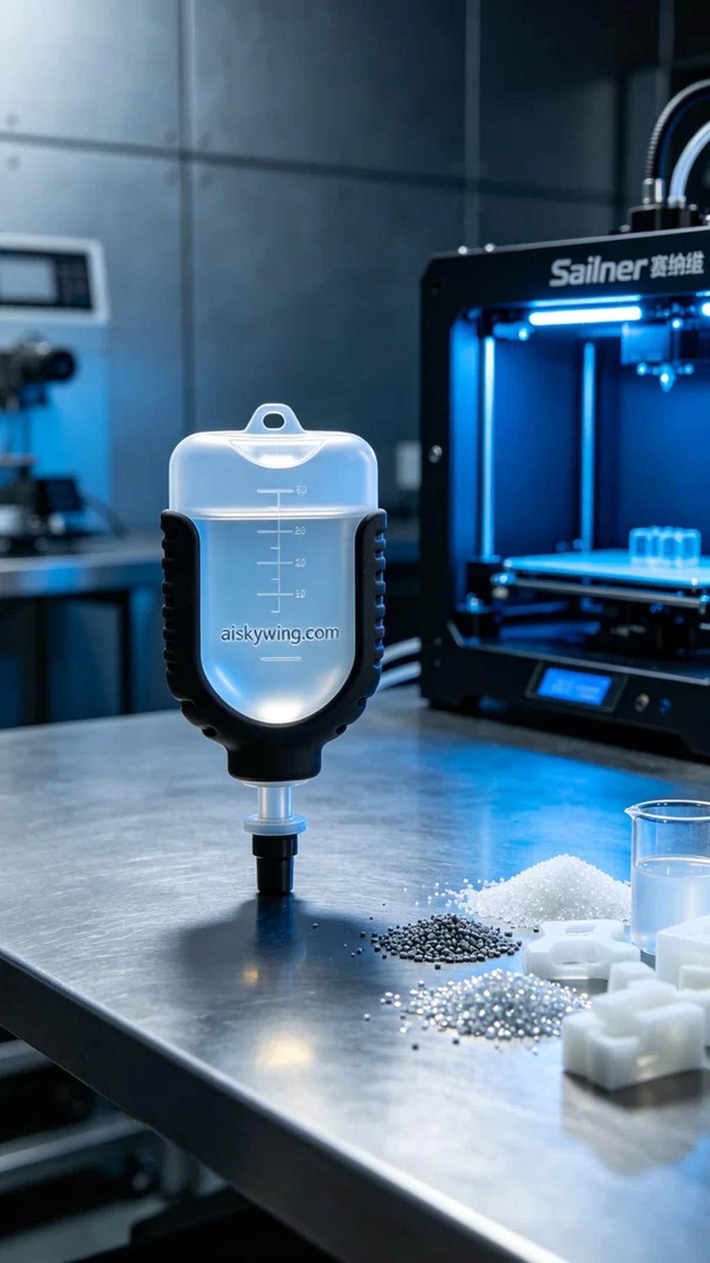
Aiskywing Industrial 3D Printing
Medical infusion drip chamber


