1121-医疗级硅胶垫生产记录
Medical-grade silicone pad
🖨️ 硅胶复模
🖥️ 打印机: Stratasys
📦 材料: 硅胶复模
生活就像一场探索，我们总在寻找解决方案。最近，有人通过WhatsApp联系我，询问医疗级硅胶垫的制作。
Life is like an exploration, and we are always searching for solutions. Recently, someone contacted me via WhatsApp to inquire about the production of medical-grade silicone pads.
________________________________________________________________________________
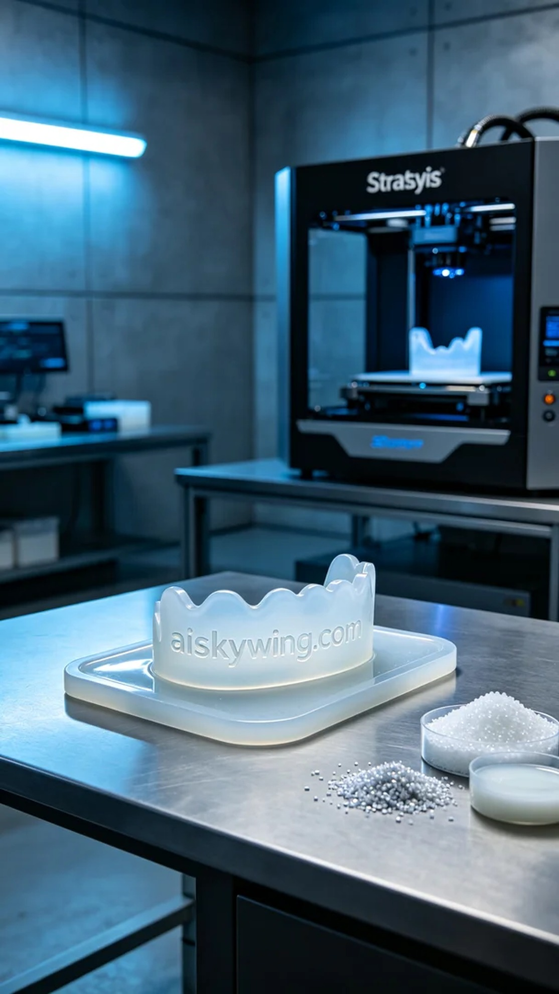
Life is like an exploration, and we are always searching for solutions. Recently, someone reached out to me via WhatsApp, asking about the production of a medical-grade silicone pad.
In communicating with a healthcare professional, they expressed the need to produce a medical-grade silicone pad to provide better comfort and protection during surgical procedures. After discussing their requirements in detail, we decided to utilize silicone molding technology to accomplish this task.
We selected high-quality silicone mold material, which not only has a translucent appearance but also possesses good softness and elasticity, making it suitable for medical applications. To ensure optimal printing results, we prepared a Stratasys brand printer, setting the layer thickness to 0.1mm, maintaining a printing temperature of 60°C, and adjusting the power to 80W for the best performance.
During the printing process, the device operated smoothly, and the flow of material was good. We conducted strict quality monitoring and regularly checked for uniformity and integrity of each printed layer. The entire printing process lasted about 20 hours, during which the device remained in excellent condition without any failures.
After printing, we proceeded with thorough post-processing. First, we carefully removed the silicone pad from the printing platform and then cleaned it to eliminate any residual photopolymer resin. Next, we performed sanding to ensure smooth edges and compliance with standards. Finally, we conducted a curing process to enhance the product's durability and ensure its structural stability, followed by inspection to confirm that the silicone pad met all requirements.
In the end, this medical-grade silicone pad was successfully completed, reflecting our commitment to quality and attention to client needs, and we look forward to its important role in practical applications.
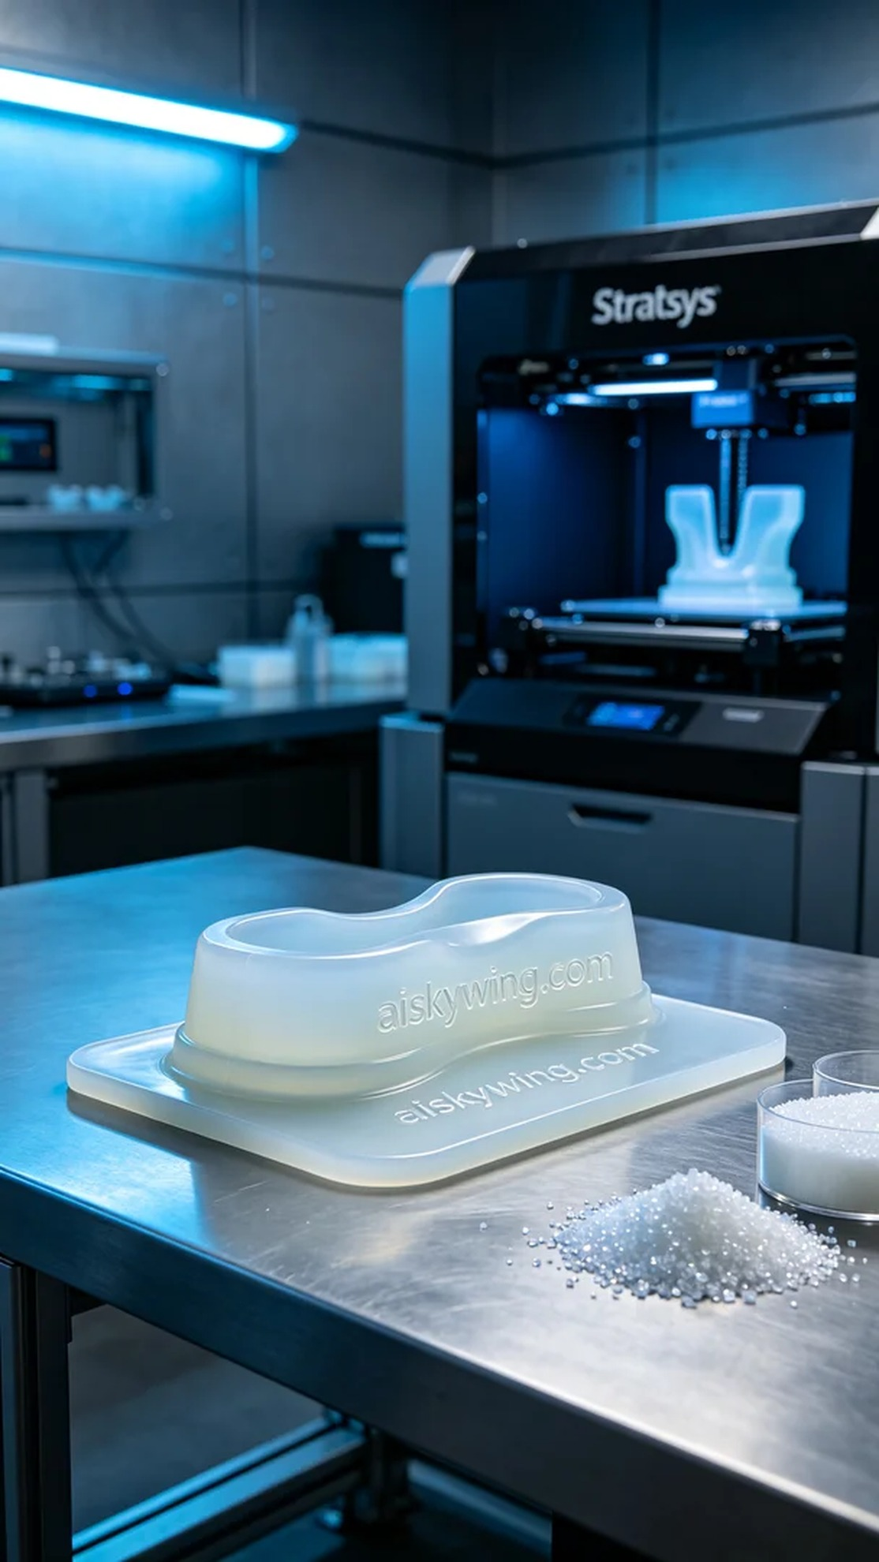
在与一位医护人员的沟通中，他们希望能够生产一款医疗级硅胶垫，因需要在手术过程中提供更好的舒适度和保护。通过WhatsApp的交流，我们详细讨论了他们的需求，并决定采用硅胶复模工艺来完成这项任务。
我们选择了优质的硅胶复模材料，这种材料不仅具有半透明的外观，还具备良好的柔软性和弹性，适合医疗用途。同时，为确保打印效果，我们准备了Stratasys品牌的打印机，设置了层厚为0.1mm，打印温度保持在60°C，功率设置为80W，以实现最佳的打印效果。
打印的过程中，设备运行顺利，材料的流动性良好，经过严格的质量监控，我们定时检查打印层的均匀性和完整度。整个打印过程持续了约20个小时，期间设备状态良好，无任何故障。
完成打印后，我们进行了详细的后处理。首先，将硅胶垫从打印平台上小心取下，随后进行清洗，以去除残留的光敏树脂。接着，通过打磨处理平整边缘，确保每个细节都符合标准。最后，我们进行了固化处理，以增强产品的耐用性并确保其形态稳定，检验后确认硅胶垫符合要求。
最终，这款医疗级硅胶垫顺利完成，体现了我们对品质的坚持和对客户需求的重视，期待它在实际应用中发挥重要作用。
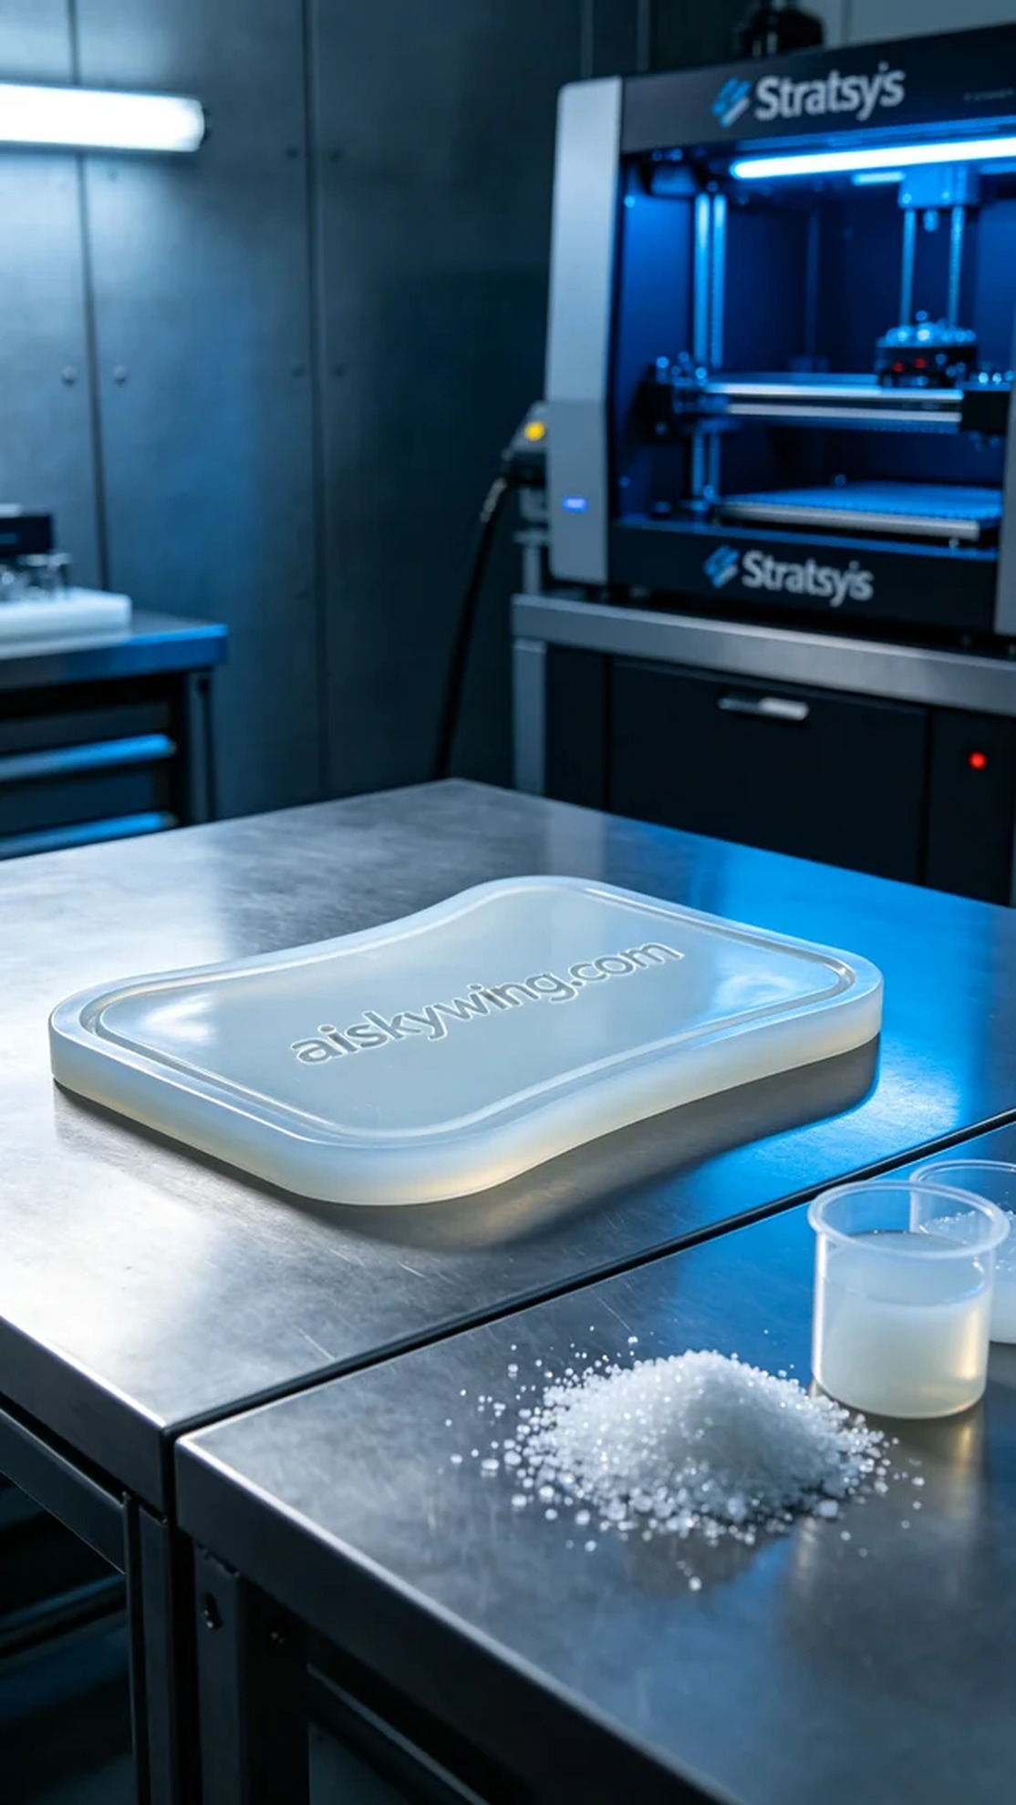
Aiskywing Industrial 3D Printing
Medical-grade silicone pad


