1122-压缩机密封垫3D打印生产记录
Compressor sealing gasket
🖨️ 硅胶复模
🖥️ 打印机: Stratasys
📦 材料: 硅胶复模
生活就像在TikTok上短暂的瞬间，时而闪光，时而平淡。最近，我们接到了一个关于压缩机密封垫的项目，让我再次体会到做事情的坚持与用心。
Life is like the fleeting moments on TikTok, sometimes dazzling, sometimes ordinary. Recently, we received a project about compressor seals, which made me once again appreciate the persistence and dedication involved in getting things done.
________________________________________________________________________________
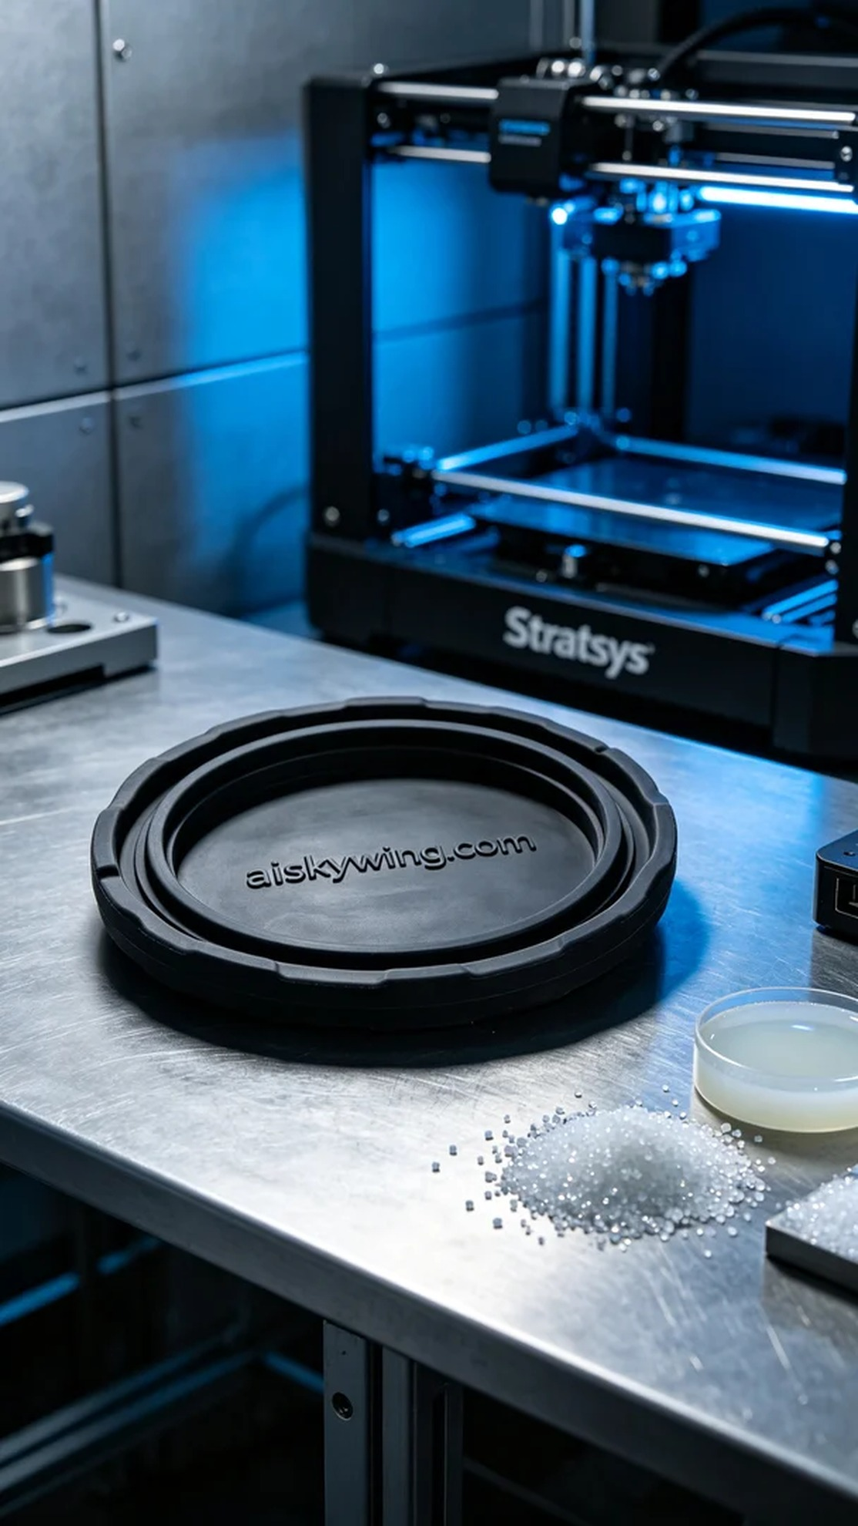
Life is like a fleeting moment on TikTok, sometimes shining, sometimes mundane. Recently, we received a project for a compressor seal that reminded me once again of the importance of persistence and dedication in our work.
The project aimed to address an issue faced by someone regarding seal failure in their compressor, who sought our help in designing a high-performance compressor seal. We decided to use silicone molding material to achieve the best performance in terms of flexibility and durability.
We utilized high-quality black silicone molding, known for its excellent flexibility and anti-slip texture, which is crucial for the sealing performance of the compressor. To ensure the print quality, we chose the Stratasys brand 3D printer, setting a layer thickness of 0.1 mm, printing temperature of 60°C, a speed of 30 mm per second, with an estimated printing time of 5 hours.
The printing process went smoothly, and I kept a close eye on quality throughout. Thanks to the Stratasys printer, every layer bonded perfectly, and the details of the compressor seal, especially the engraved "aiskywing.com" lettering, were clearly visible.
After printing, we moved into the post-processing phase. First, we cleaned the printed part with a detergent to remove any residues; then, we sanded it for a smoother surface; finally, we cured it to enhance the silicone’s strength and durability. After rigorous inspection, this compressor seal met our expectations.
In conclusion, this project not only solved the sealing issue but also reinforced the significance of taking every detail seriously. Our hard work finally bore fruit.
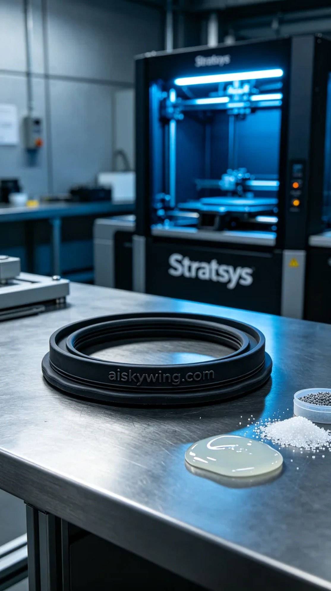
这次的项目是为了应对有人在使用压缩机时遇到的密封失效问题，找我们希望能设计出一款高性能的压缩机密封垫。为此，我们选择了硅胶复模材质，力求在柔韧性和耐磨性上达到最佳效果。
在原材料方面，我们使用了优质的黑色硅胶复模，具备良好的柔性和防滑纹理，这对于压缩机的密封性能至关重要。为了确保打印质量，我们选用Stratasys品牌的3D打印机，设置了层厚0.1毫米，打印温度为60°C，打印速度保持在30毫米每秒，预计打印时间为5小时。
打印开始后，设备运行非常顺利。整个打印过程中，我始终保持着对质量的监控，确保每一层都能够完美粘合。在Stratasys打印机的帮助下，压缩机密封垫的细节得以清晰呈现，特别是雕刻的“aiskywing.com”字样，更是清晰可见。
完成打印后，我们进入了后处理阶段。首先，使用洗涤剂对打印件进行清洗，以去除残留物；接着进行打磨，使其表面更加光滑；最后，进行固化处理，以增强硅胶的强度和耐用性。经过严格检验，这款压缩机密封垫达到了预期的效果。
最后，这个项目不仅解决了压缩机的密封问题，还让我再次感受到认真对待每一个细节的重要性。我们的努力终于开花结果了。
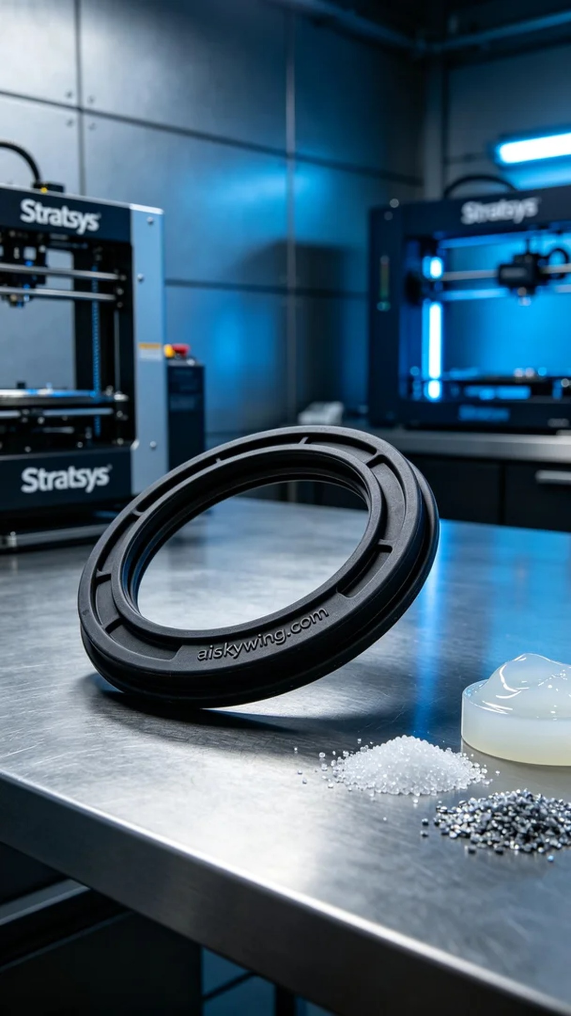
Aiskywing Industrial 3D Printing
Compressor sealing gasket


