1123-双唇密封圈的3D打印生产记录
Double lip seal
🖨️ 硅胶复模
🖥️ 打印机: Xjet
📦 材料: 硅胶复模
生活的每一步都有其意义，就像接受这个双唇密封圈的订单，虽然艰辛，但终将成就一份完美。
Every step in life has its meaning, just like accepting the order for this double-lip seal. Although it is challenging, it will ultimately lead to the achievement of perfection.
________________________________________________________________________________
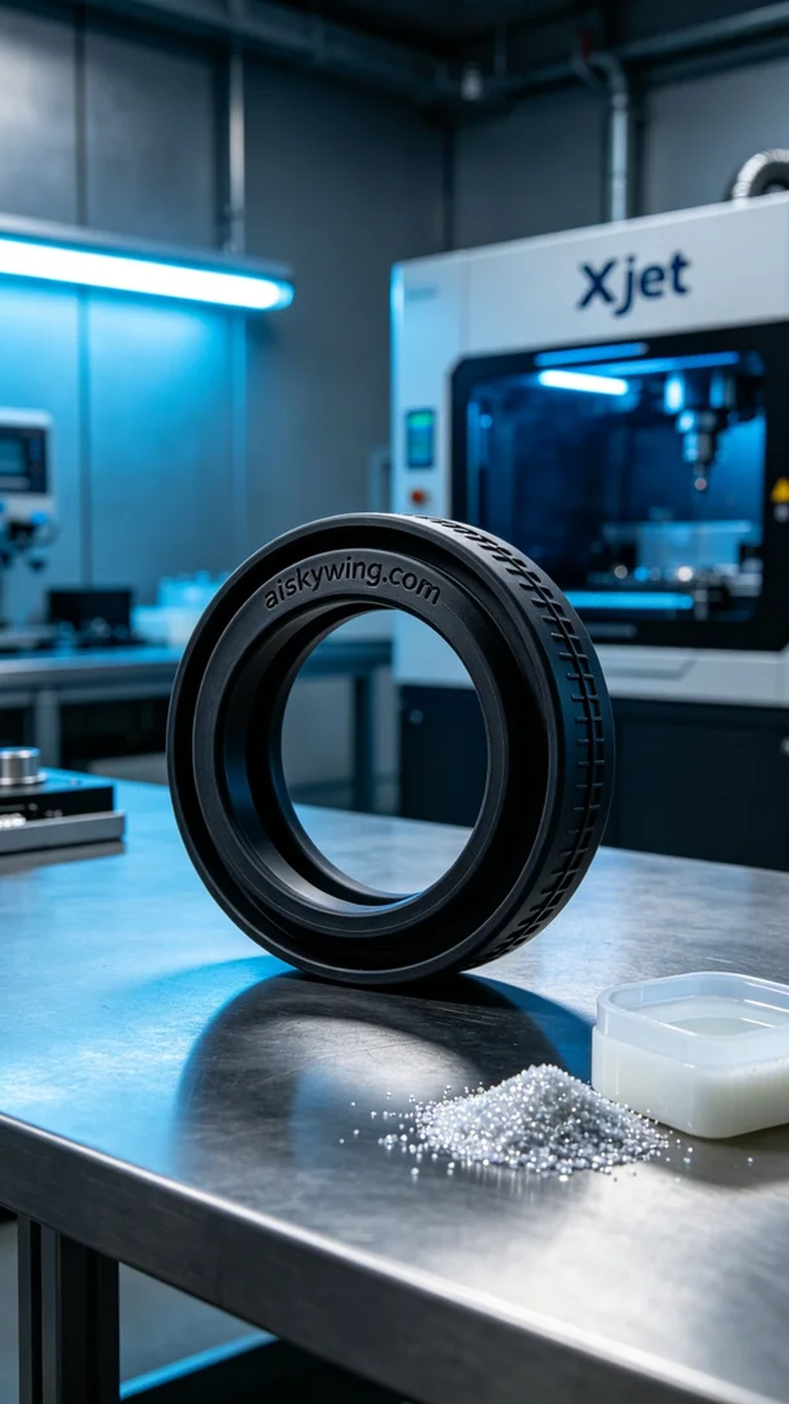
Every step in life has its significance, much like accepting the order for this dual lip sealing ring. Though challenging, it will ultimately lead to achieving perfection.
On the social media platform Twitter, someone reached out to us seeking a solution to a common issue: how to provide a high-quality, durable dual lip sealing ring for their product. After in-depth discussions, we finalized their needs and began preparations for this project.
We chose silicone rubber as the primary material due to its elasticity, durability, and excellent anti-slip properties, making it ideal for manufacturing sealing rings. In terms of equipment preparation, we utilized the Xjet brand 3D printer. To ensure optimal printing results, we set the layer thickness to 0.1mm, print temperature to 25°C, power to 70%, print speed to 40mm per second, with an estimated print time of two hours.
During the printing process, the Xjet printer operated smoothly while we conducted quality monitoring. Each layer was precisely controlled to ensure the sealing ring's dimensions and shape remained consistent. The machine moved steadily, with the liquid photopolymer resin flowing evenly on the print bed, free of bubbles or impurities, ensuring an excellent final outcome.
Once printing was complete, we carried out strict post-processing. First, the printed sealing rings were placed in a cleaning tank, using alcohol to remove excess resin from the surface. Subsequently, we meticulously sanded them to achieve a smooth, flawless finish. After that, curing was performed by placing the sealing rings under UV light to ensure their strength and durability. Finally, we thoroughly inspected each sealing ring to confirm they met the required standards.
After a series of meticulous procedures, we successfully completed this project. Every detail was closely monitored, resulting in a flawless dual lip sealing ring.
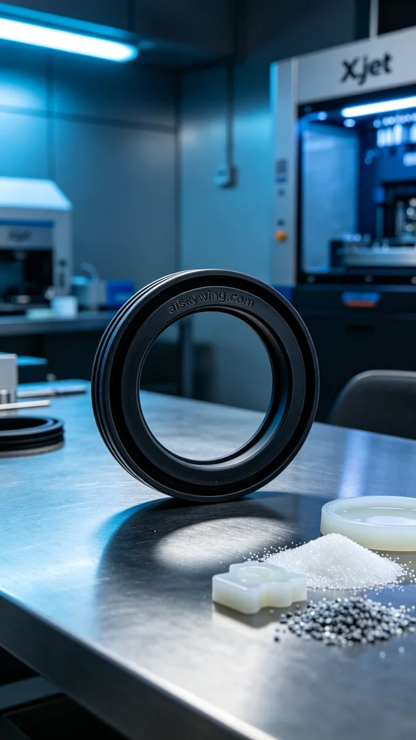
在社交媒体平台Twitter上，有人找到了我们，希望解决一个常见的问题：如何为他们的产品提供一个高质量、耐用的双唇密封圈。经过深入交流，确定了需求后，我们开始了这个项目的准备工作。
我们选择了硅胶复模作为主要材料，这种材料具备弹性、耐用性和良好的防滑特性，适合用于密封圈的制造。在设备准备方面，我们使用了Xjet品牌的3D打印机。为了确保打印的效果，设定了层厚为0.1毫米，打印温度为25℃，功率设定在70%，打印速度为40毫米每秒，预计打印时间为两小时。
在打印过程中，Xjet打印机平稳运行，整个过程我们都在进行质量监控。每一层的打印都在精确控制之下，确保了密封圈的尺寸和形状保持一致。机器的移动平稳，液态光敏树脂在打印平台上均匀流动，无气泡或杂质产生，确保了最终效果。
完成打印后，我们进行了严格的后处理工序。首先将打印好的密封圈放入清洗槽中，用酒精进行清洗，去除表面多余的树脂。接着对其进行细致打磨，确保表面光滑无瑕疵。之后，进行了固化处理，将密封圈放置在紫外线灯下进行固化，确保其强度和耐久性。最后，通过仔细检验，确认每一个密封圈都符合标准。
经过一系列细致入微的工序，我们成功完成了这个项目。每一个细节的把控，最终成就了一个完美的双唇密封圈。
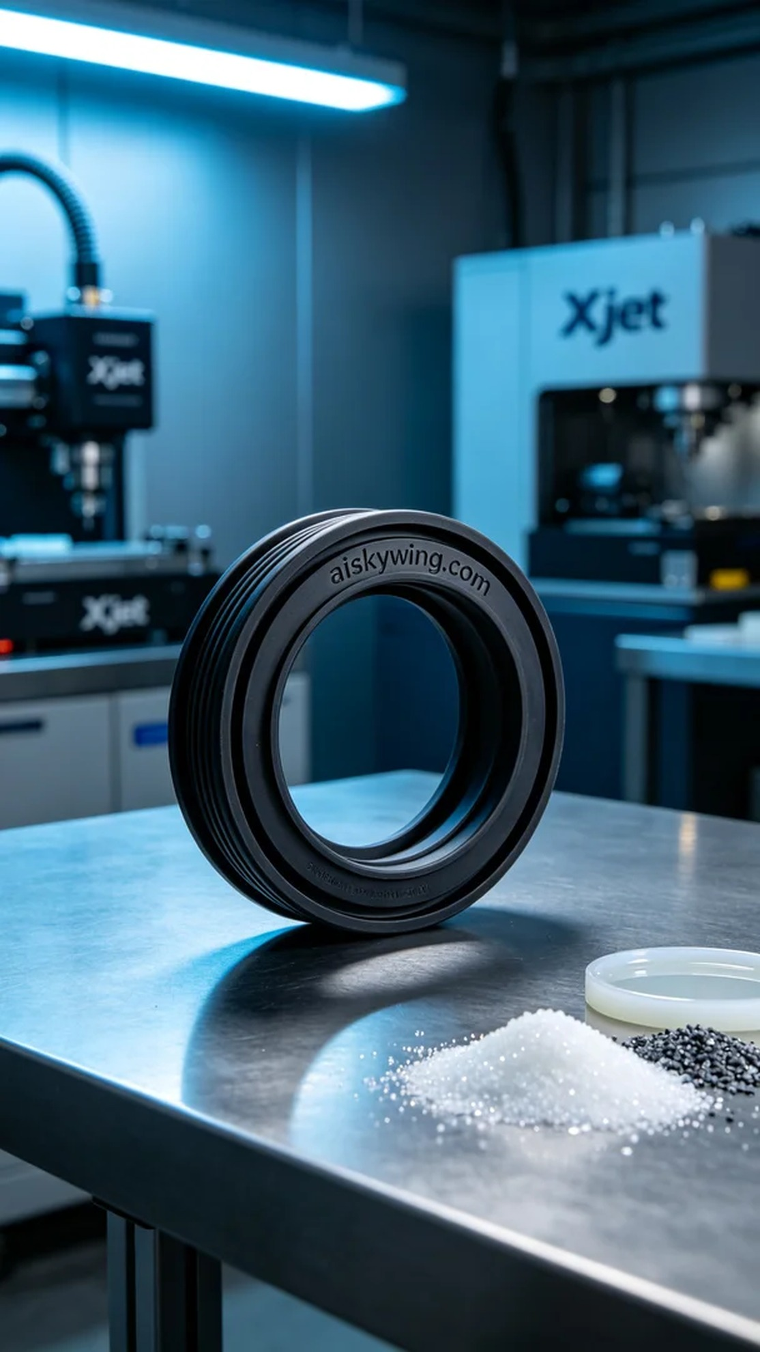
Aiskywing Industrial 3D Printing
Double lip seal


