1124-发动机密封垫的3D打印生产记录
Engine gasket
🖨️ 硅胶复模
🖥️ 打印机: Voxeljet
📦 材料: 硅胶复模
生活就像一场及时雨，有时总会有人在WhatsApp上找到我们，寻找解决方案。就像我们这次接到的发动机密封垫的制作需求。
Life is like a timely rain; sometimes someone will find us on WhatsApp, looking for solutions. Just like the request we received this time for the production of engine gaskets.
________________________________________________________________________________
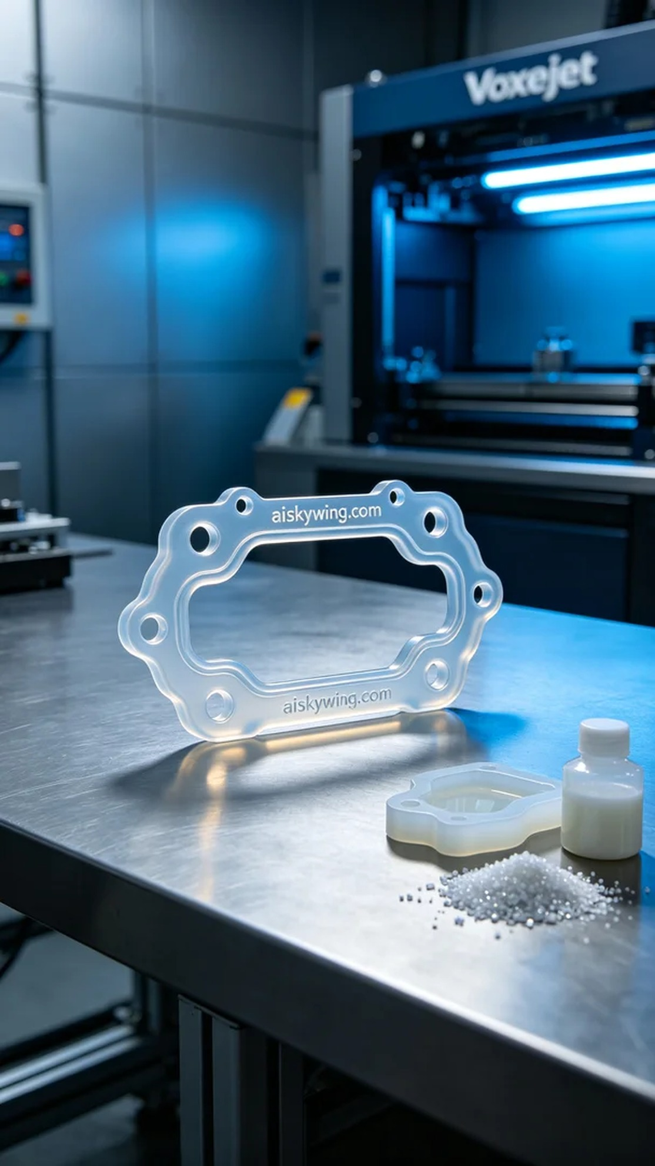
Life is like a timely rain; sometimes, someone reaches out to us on WhatsApp, seeking solutions. This time, we were contacted to produce an engine gasket.
A friend approached us, asking if we could create an engine gasket due to the aging of the original part, which was no longer effective in preventing oil leaks. We decided to use silicone molding material to ensure a durable and effective seal.
We chose the Voxeljet printer for production. The silicone molding material has superior properties, being transparent and soft, allowing for an ergonomic fit. For the printing parameters, we set the layer thickness to 0.1mm, the temperature at 25°C, power at 120W, and a printing speed of 30mm/s, expecting the entire process to take around 3 hours.
During the printing process, the machine operated smoothly, and we monitored the workflow closely. We paid special attention to the printing quality, ensuring even adhesion for each layer, free from bubbles or impurities. After some time, the engine gasket started taking shape, and details became sharper.
The post-processing phase was equally important. Once printing was done, we cleaned the gasket to remove any residual resin on the surface. We then carefully polished it to ensure smooth edges, not compromising the sealing performance. Finally, we cured it under UV light to enhance material strength, performing thorough inspections to ensure quality before delivery.
Through this production task, we not only delivered a practical product but also honed our technical skills in the process. The successful creation of the engine gasket brought us immense satisfaction.
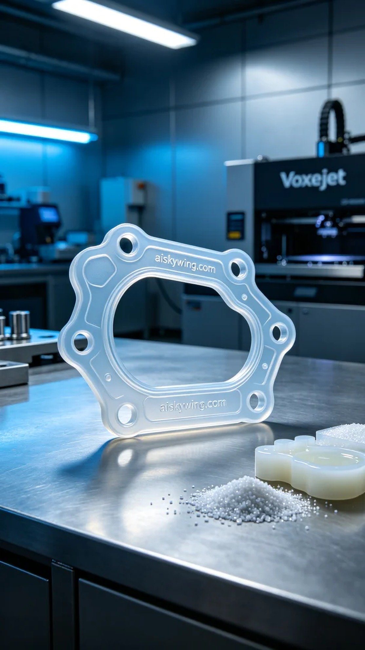
这次接到的任务是一位朋友通过WhatsApp联系到我们，询问能否制作一款发动机密封垫。由于原有密封垫老化磨损，无法有效防止漏油。我们决定使用硅胶复模材料，以确保密封效果和耐用性。
我们选择了Voxeljet打印机进行生产。硅胶复模材料特性优越，具备透明柔软的特点，能够人体工学贴合设计。打印参数方面，设置层厚为0.1mm，温度控制在25°C，打印功率为120W，打印速度为30mm/s，整个打印过程预计需要3小时。
在打印过程中，设备运转稳定，整个流程监控严密。我们注重观察打印质量，确保每一层的粘合都均匀，表面无气泡和杂质。经过一段时间的运作，发动机密封垫逐渐显现出它的形状，细节也愈加清晰。
后处理环节同样重要。打印完成后，我们进行了清洗，去掉了表面的残留树脂。接着进行了仔细打磨，以确保边缘光滑，不影响密封效果。最后，将其放入UV灯下固化，以增强材料强度，经过检验，确保达到标准后才准备交付。
通过这次制作，我们不仅完成了一个实用的产品，也在不断的实践中提升了自身的技术能力。发动机密封垫的成功制作，让我们感到无比欣慰。
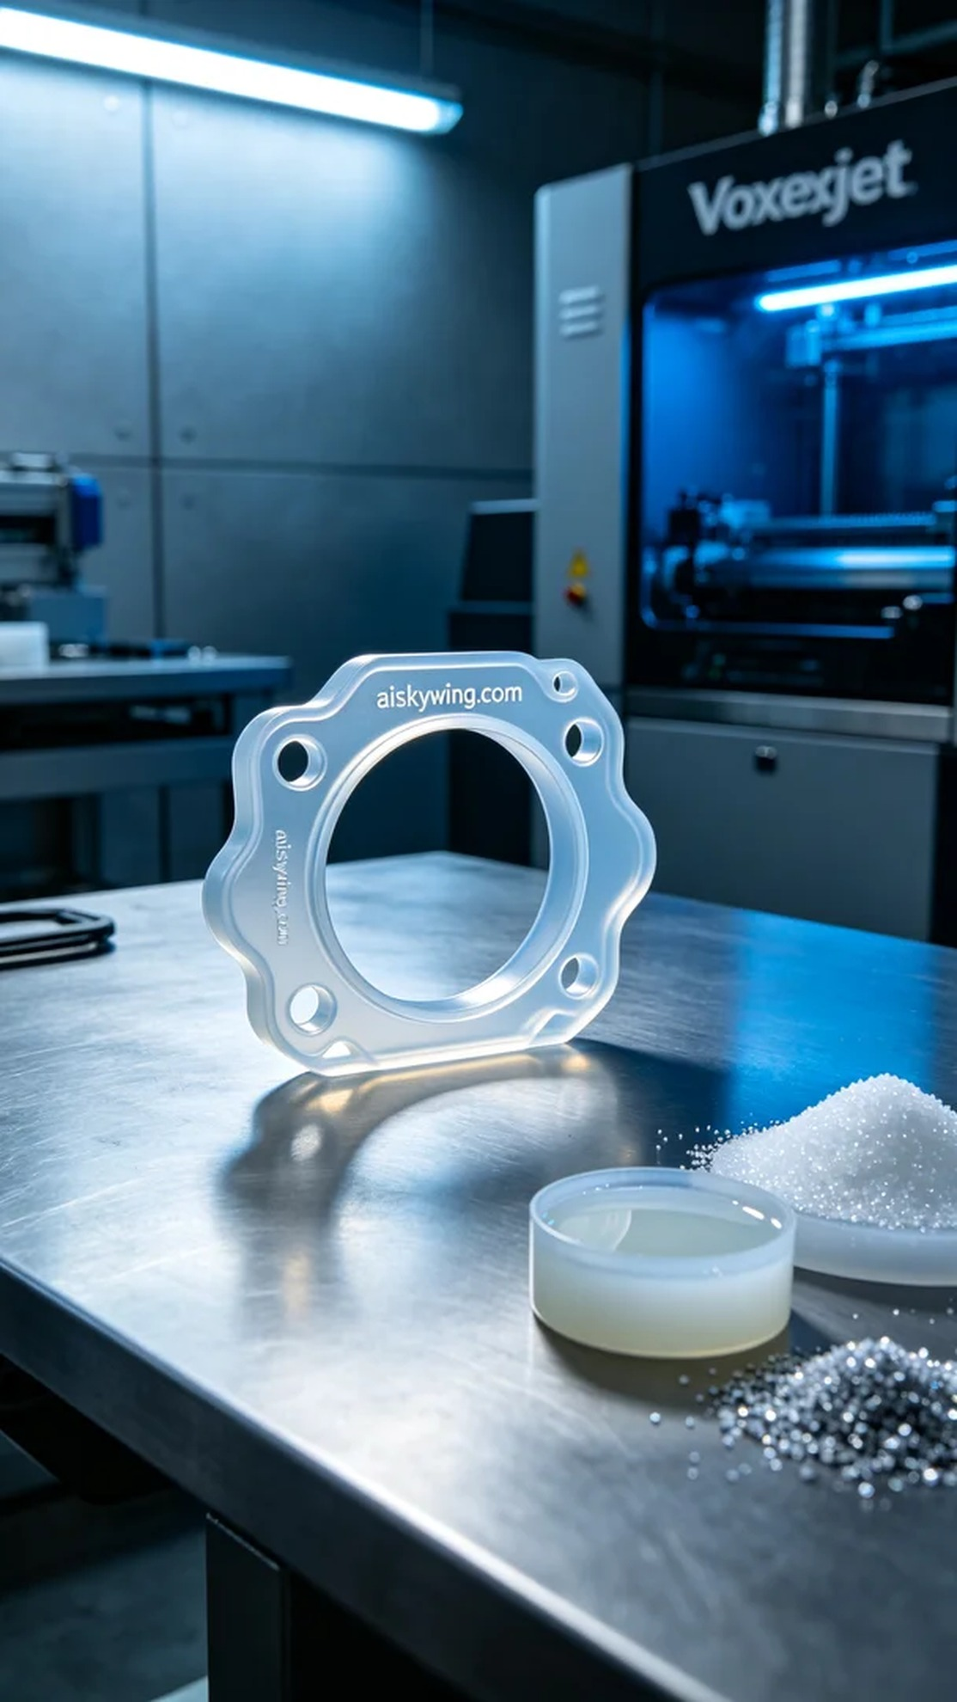
Aiskywing Industrial 3D Printing
Engine gasket


