1125-变速箱密封垫的3D打印之旅
Transmission gasket
🖨️ 硅胶复模
🖥️ 打印机: Stratasys
📦 材料: 硅胶复模
生活就像3D打印的过程，总有些意外和挑战。最近有人通过WhatsApp找我，想要我们制作变速箱密封垫，着急解决问题。
Life is like the process of 3D printing, always full of surprises and challenges. Recently, someone contacted me through WhatsApp, wanting us to produce a gearbox seal quickly to solve a pressing issue.
________________________________________________________________________________
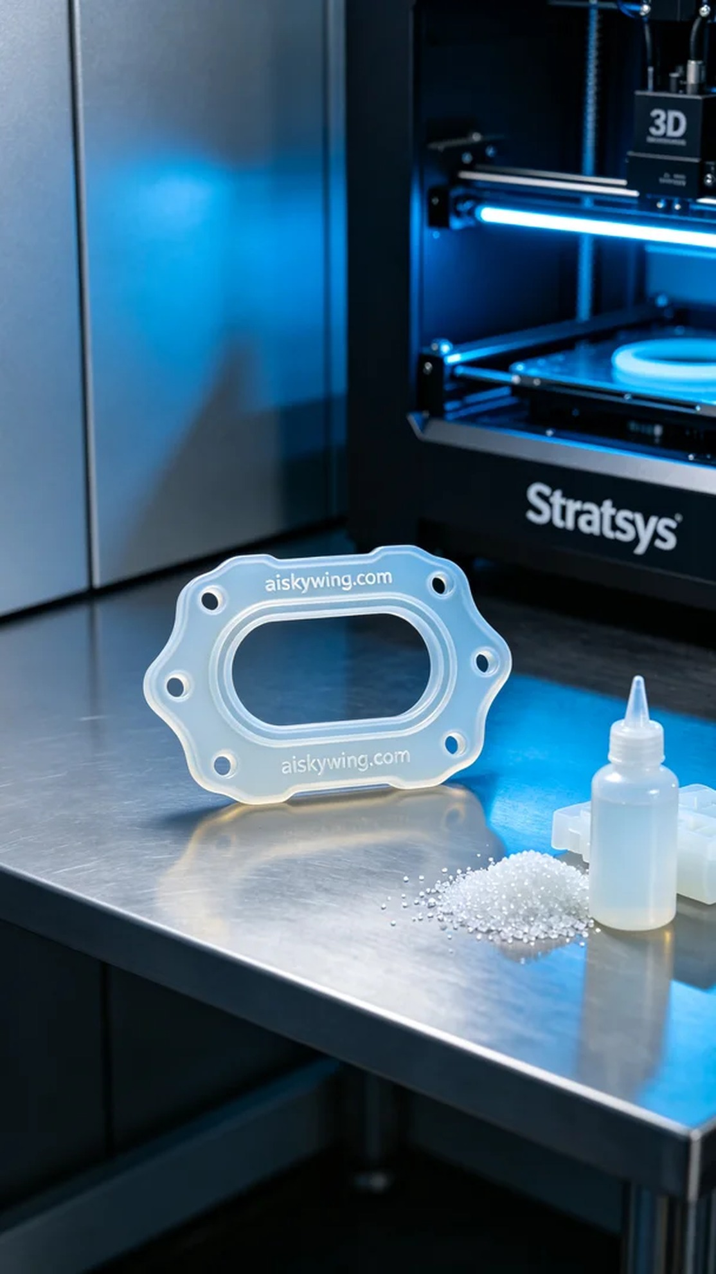
Life is much like the process of 3D printing, full of surprises and challenges. Recently, someone reached out to me via WhatsApp, urgently needing a gearbox sealing gasket to address a leaking issue.
To create this gearbox sealing gasket, we chose medical-grade silicone mold material, which is translucent and offers excellent elasticity and softness, perfectly meeting the sealing requirements. Next, we used a Stratasys printer for the printing process, setting a layer thickness of 0.1 mm, maintaining a printing temperature of 25 degrees Celsius, a power setting of 80 watts, and a printing speed of 30 mm per second, with an estimated printing time of about 90 minutes.
During the printing process, the Stratasys printer operated smoothly, extruding the material efficiently. We continuously monitored the quality to ensure that each layer adhered perfectly, avoiding common issues like warping and layer separation. As the print progressed, the contours of the gearbox sealing gasket became clearer, and the engraved “aiskywing.com” text became increasingly prominent.
Once printing was complete, we entered the post-processing stage. First, we cleaned the formed gasket with a cleaning agent to remove excess resin. Then, we proceeded with sanding to ensure a smooth surface free of burrs, followed by a curing process where we used UV light for 30 minutes to enhance the strength and durability of the silicone material. After a rigorous inspection, we confirmed the product met the standards before delivery.
Through this project, we not only addressed the urgent production need but also improved our team’s collaboration and efficiency. The gearbox sealing gasket is not just a product; it is a testament to our commitment to quality and service.
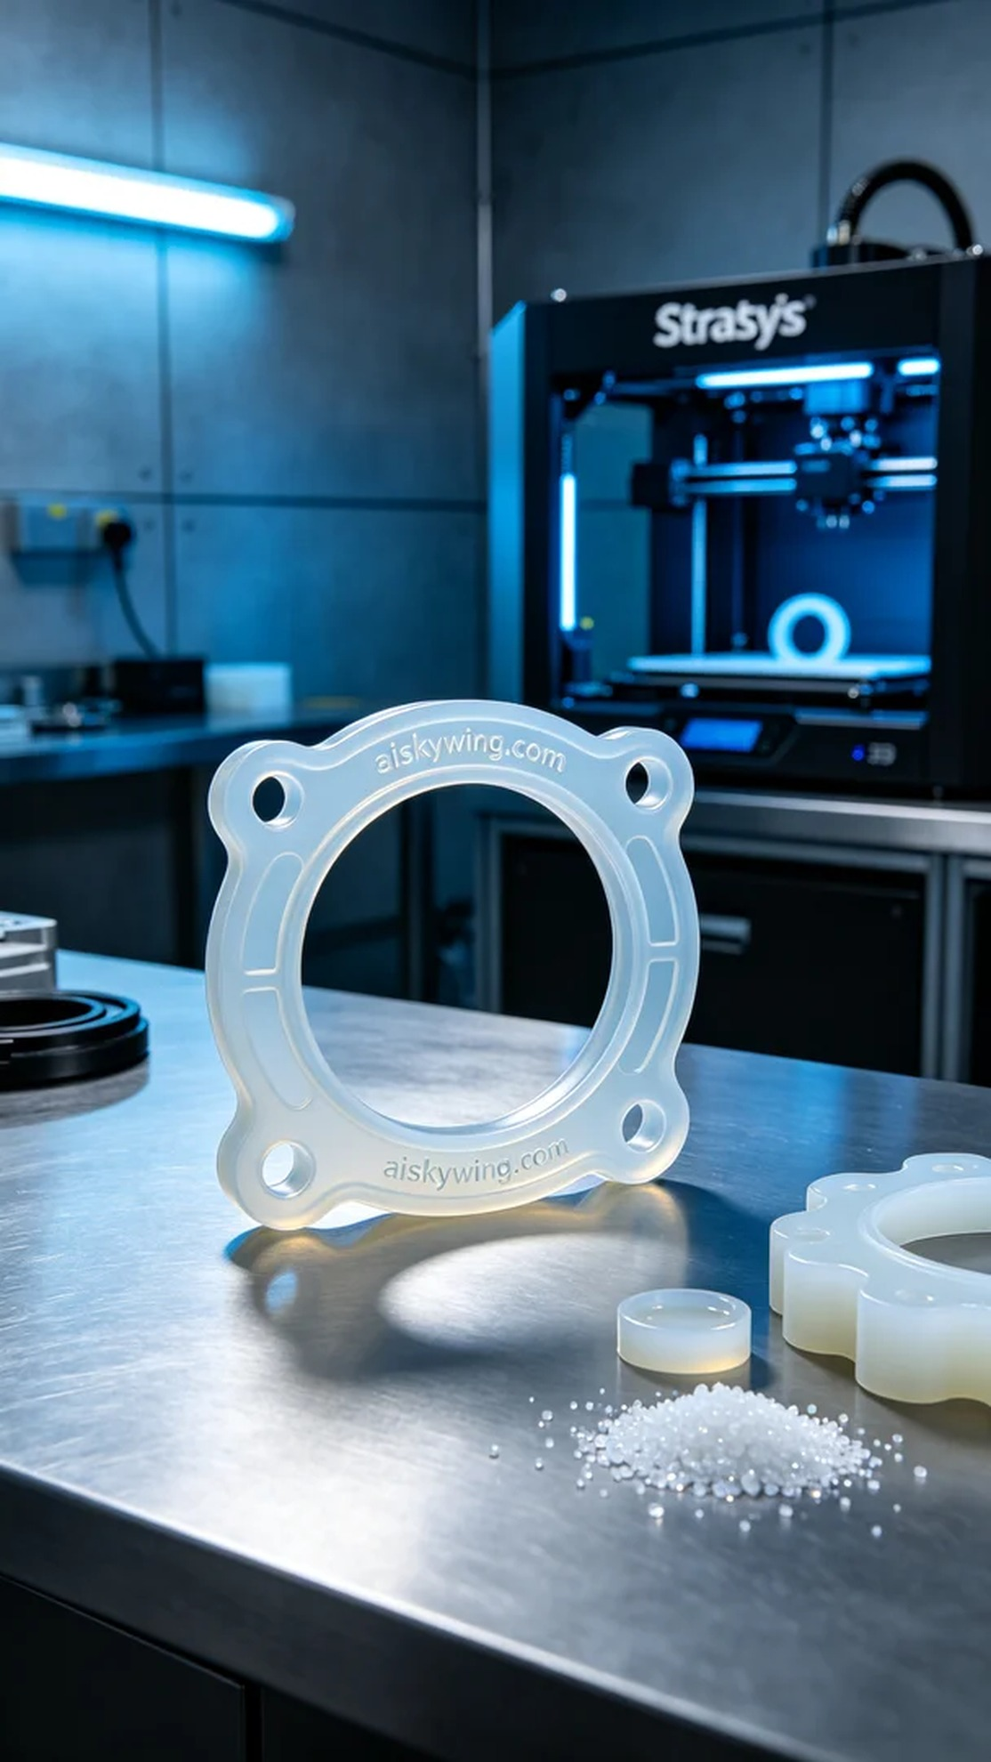
在接到来自WhatsApp的信息后，有人因为车间的变速箱漏油问题，急需一款变速箱密封垫。他们希望我们能够快速制作出一款高质量的密封垫，以保障设备的正常运转。
为了制作这个变速箱密封垫，我们选择了医用级硅胶复模材料，半透明且具有良好的弹性和柔软性，能够很好地满足密封需求。接下来，我们使用Stratasys打印机进行打印，设置层厚为0.1毫米，打印温度控制在25摄氏度，功率设定为80瓦，打印速度为30毫米每秒，预计打印时间约为90分钟。
在打印过程中，Stratasys打印机稳定运行，材料流畅地被挤出。我们时刻监控打印质量，确保每一层都能完美附着，避免常见的翘边和层间分离等问题。随着打印的推进，变速箱密封垫的轮廓逐渐清晰，雕刻的“aiskywing.com”字样也愈发明显。
打印完成后，我们进入后处理环节。首先，用清洗剂对成型的密封垫进行清洗，去除多余的树脂。接着进行打磨，确保表面光滑无毛刺，最后进行固化处理，使用紫外线灯照射30分钟，确保硅胶材料的强度和耐用性。经过严格检查，确认产品达到标准后，我们将其交付。
通过这次制作，我们不仅解决了紧急的生产需求，也进一步提升了团队的协作与效率。变速箱密封垫不仅是一个产品，更是我们对品质与服务的坚持。
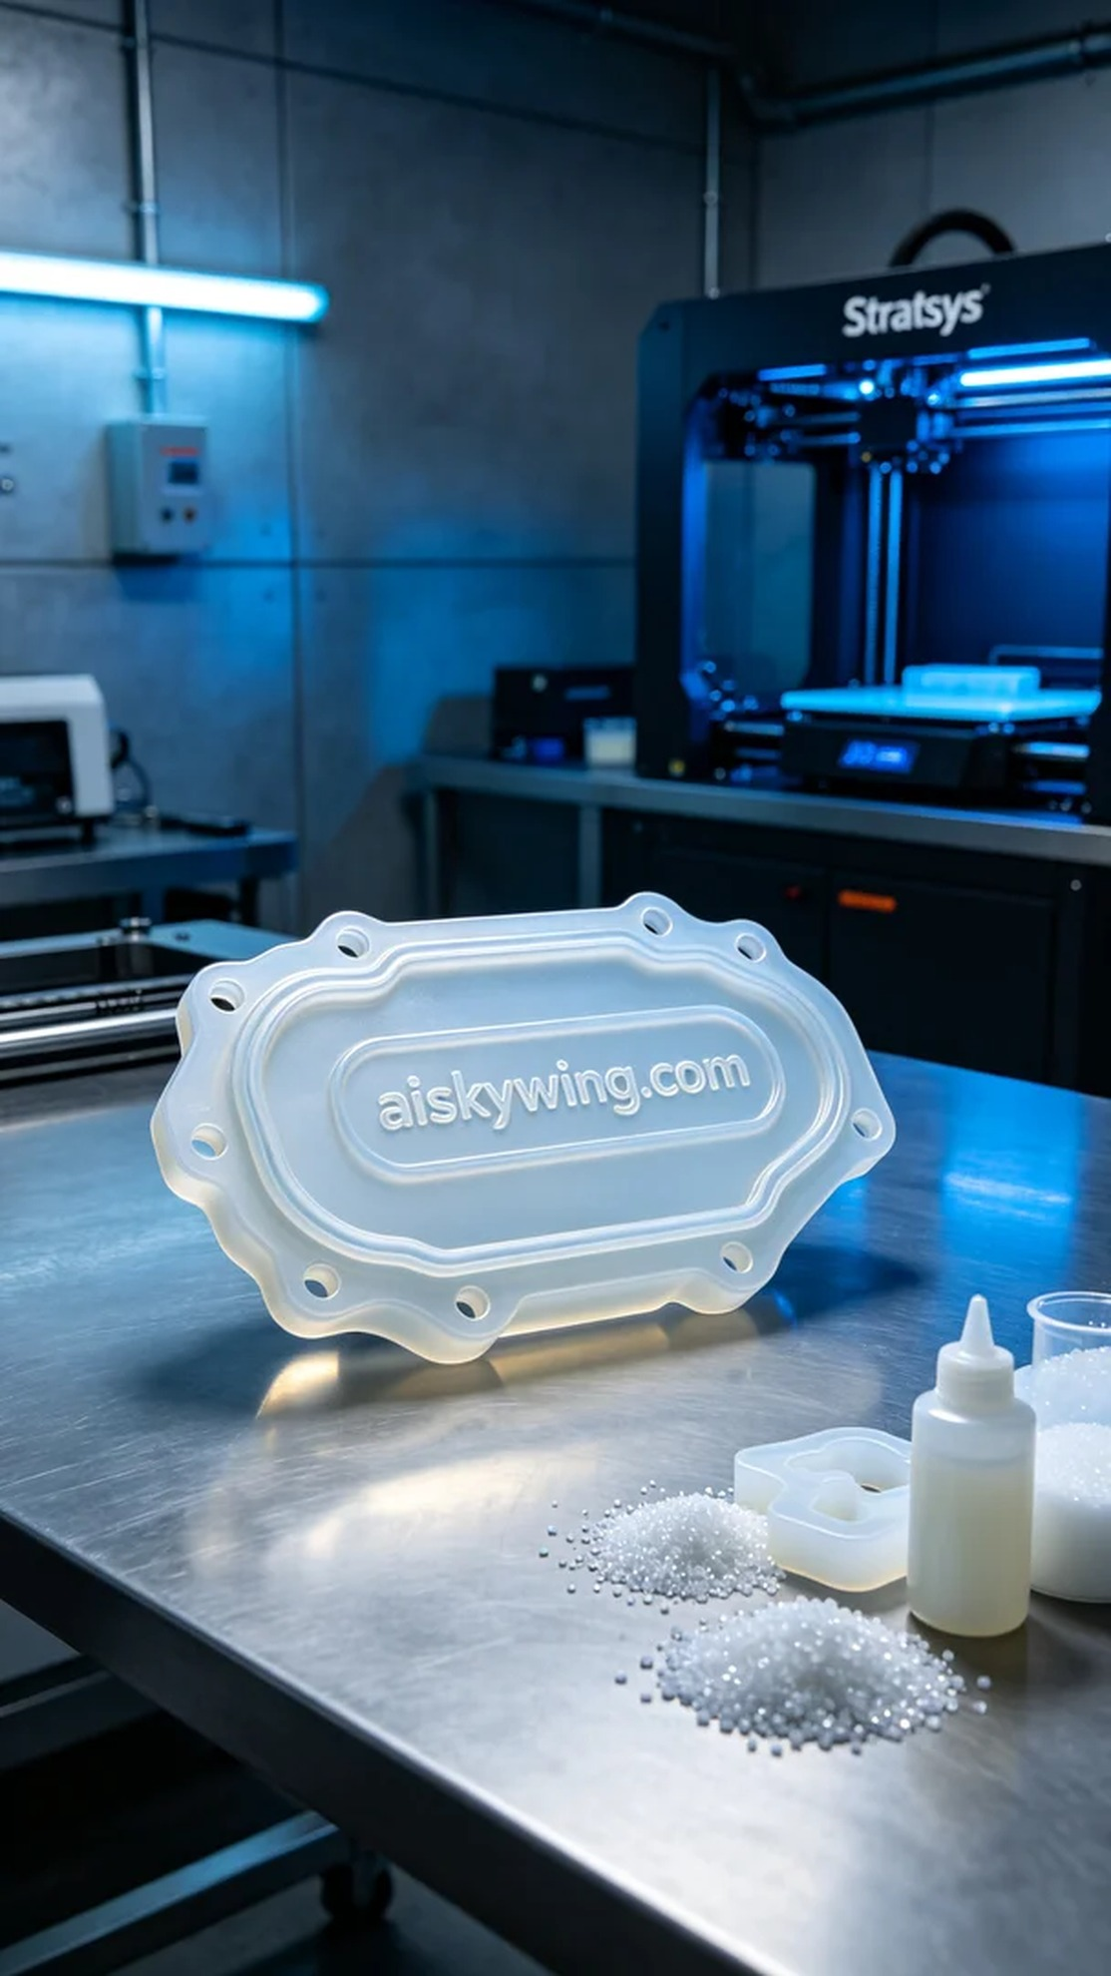
Aiskywing Industrial 3D Printing
Transmission gasket


