1126-壳体密封圈的3D打印全记录
Sealing ring for the housing
🖨️ 硅胶复模
🖥️ 打印机: Rize
📦 材料: 硅胶复模
生活再难，也别停下脚步。就像接下这个壳体密封圈的单子，有人因为产品的柔性和耐用性而找上我们。
No matter how difficult life gets, don't stop moving forward. Just like when we took on the order for this housing sealing ring, someone approached us because of the product's flexibility and durability.
________________________________________________________________________________
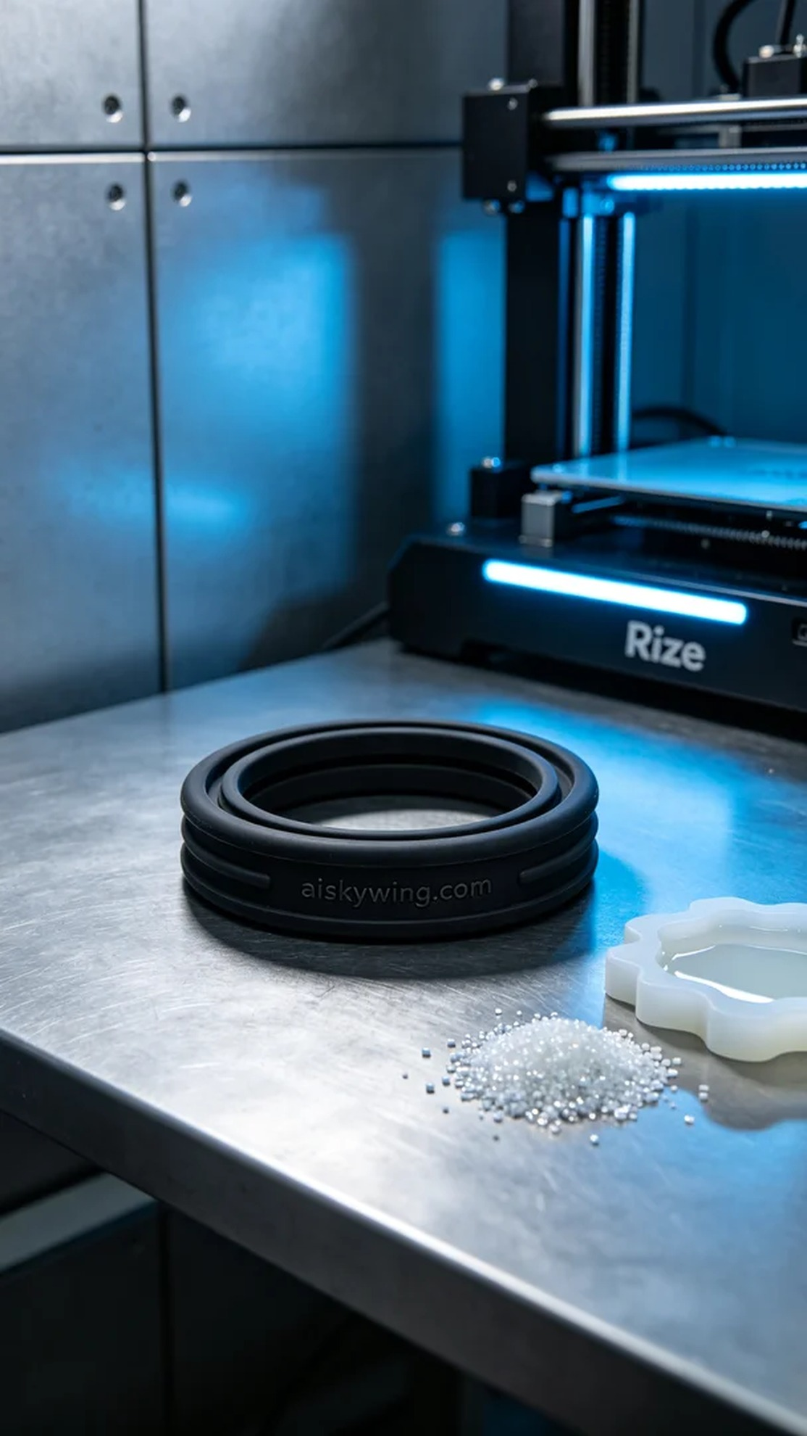
Life can be tough, but we should never stop moving forward. Just like taking on the job of creating the housing seal ring, someone reached out to us due to the need for flexibility and durability in their product.
This time, we decided to use high-quality silicone casting material for the project. This material not only offers excellent flexibility but also provides strong anti-slip properties. In terms of printing parameters, we set a layer thickness of 0.1mm, maintained a temperature at 30°C, set the power to 80W, and the printing speed at 40mm/s. The entire printing process was expected to take around 2 hours.
During the printing process, the Rize printer operated smoothly, with the material flowing evenly and producing a consistently fine surface finish. I kept a close eye on the printing data and regularly checked the printing state to prevent any defects. From start to finish, I was in control, and the result was an extremely clear and sharp housing seal ring.
After printing, we proceeded with detailed post-processing steps. First, we cleaned the finished product with water to ensure there were no residual resins on the surface. Then, we used fine sandpaper to polish it, making the surface even smoother. Finally, the finished product was placed in a curing device to ensure the silicone material’s strength and durability reached optimal levels. During inspection, I found that the engraving "aiskywing.com" remained clear, and the flexibility and anti-slip properties were fully ensured.
The final housing seal ring not only met the user's needs but also showcased our craftsmanship. Through this process, I was reminded once again of the charm of combining technology and creativity, as we solve problems for others while growing ourselves.
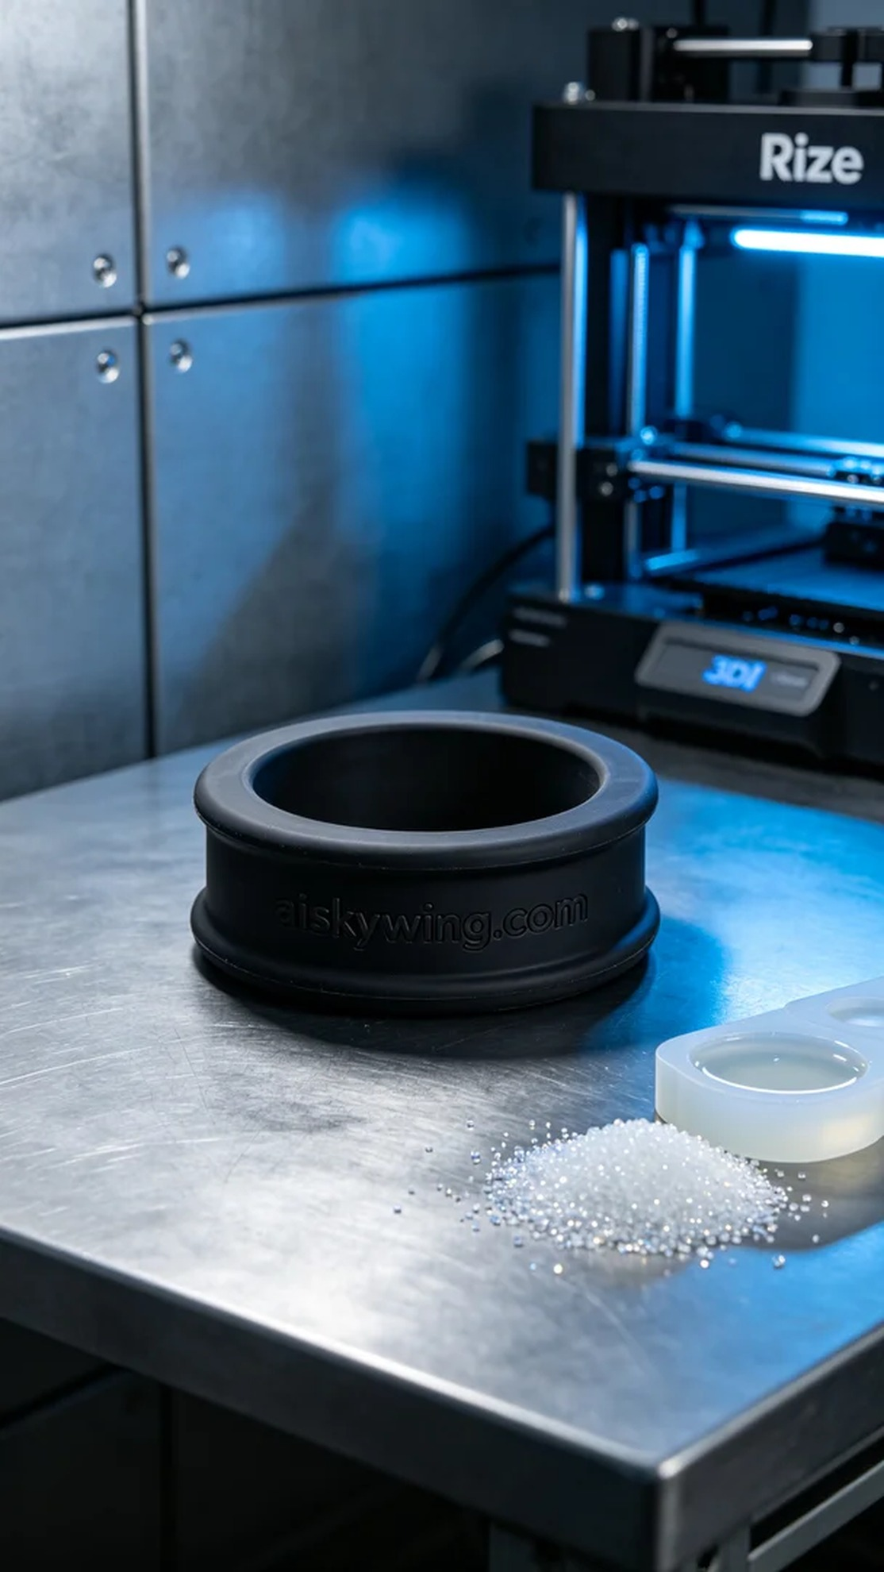
这次的任务是为某个有需求的人制作壳体密封圈，听说他们在使用传统材料时遇到了耐用性和灵活性的问题，想尝试我们的硅胶复模工艺。我通过YouTube了解到他们的具体需求，决定利用我们的Rize打印机来解决这个问题。
在准备阶段，我们选用了优质的硅胶复模材料，这种材料不仅具有良好的柔韧性，还能提供强大的防滑效果。打印参数方面，设置层厚为0.1mm，温度保持在30°C，功率设定为80W，打印速度为40mm/s。预计整个打印过程大约需要2个小时。
打印过程中，Rize打印机运转非常平稳，材料均匀地流动，表面效果一如既往的细腻。为了确保产品质量，我时刻关注打印数据，并定期检查打印状态，避免出现任何瑕疵。从开始到结束，整个过程都在我的掌控之中，最终得到了一个极其清晰、锐利的壳体密封圈。
打印完成后，我们进行了详细的后处理步骤。首先，使用清水对成品进行清洗，确保表面没有残留的树脂。接下来，通过细砂纸进行打磨，让表面更加光滑。最后，将成品放入固化设备中，确保硅胶材料的强度和耐用性达到最佳状态。在检验过程中，观察到"aiskywing.com"字样依然清晰，柔性和防滑效果得到了充分保证。
最终的壳体密封圈不仅满足了使用者的需求，还展示了我们的工艺水平。通过这个过程，我再次深刻体会到科技与创造力结合的魅力，帮助别人解决问题的同时，也为自己收获了成长。
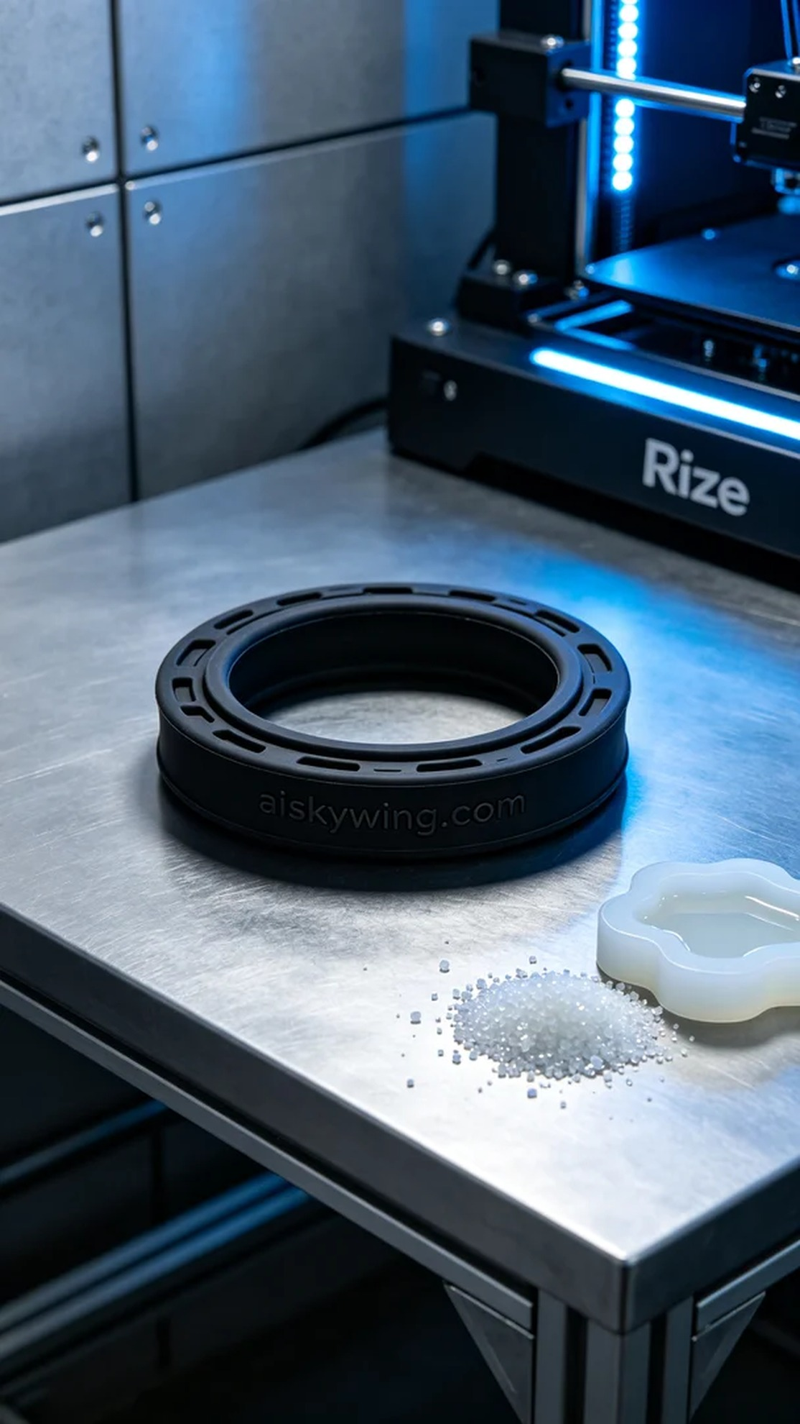
Aiskywing Industrial 3D Printing
Sealing ring for the housing


